**GRAPHS**

**We need to install networkx and matplotlib. In Terminal, type:**

**pip install networkx** and **pip install matplotlib.**

Problem 1. How to draw an undirected graph using NetworkX in Python?

import networkx as nx  
import matplotlib.pyplot as plt  
  
G = nx.Graph()  
G.add_edges_from(  
 [('A', 'B'), ('A', 'C'), ('D', 'B'), ('E', 'C'), ('E', 'F'),  
 ('B', 'H'), ('B', 'G'), ('B', 'F'), ('C', 'G')])  
  
nx.draw(G)  
  
plt.show()

Problem 2. How to draw an directed graph using NetworkX in Python?

import networkx as nx  
import matplotlib.pyplot as plt  
  
G = nx.DiGraph()  
G.add_edges_from(  
 [('A', 'B'), ('A', 'C'), ('D', 'B'), ('E', 'C'), ('E', 'F'),  
 ('B', 'H'), ('B', 'G'), ('B', 'F'), ('C', 'G')])  
  
nx.draw(G)  
  
plt.show()

Problem 3. How to draw a graph with labels?

import networkx as nx  
import matplotlib.pyplot as plt

G = nx.DiGraph()  
G.add_edges_from(  
 [('A', 'B'), ('A', 'C'), ('D', 'B'), ('E', 'C'), ('E', 'F'),  
 ('B', 'H'), ('B', 'G'), ('B', 'F'), ('C', 'G')])  
  
nx.draw(G, with_labels=True)  
  
plt.show()

Problem 4. How to find shortest paths?

import networkx as nx  
G = nx.Graph()  
G.add_edge('A', 'B', weight=4)  
G.add_edge('B', 'D', weight=2)  
G.add_edge('A', 'C', weight=3)  
G.add_edge('C', 'D', weight=4)  
print(nx.shortest_path(G, 'A', 'D', weight='weight'))

EXERCISES FOR LAB 8.

1. Write a python program to redraw the following graphs

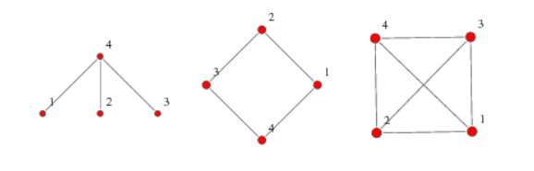

[Grab your reader’s attention with a great quote from the document or use this space to emphasize a key point. To place this text box anywhere on the page, just drag it.]

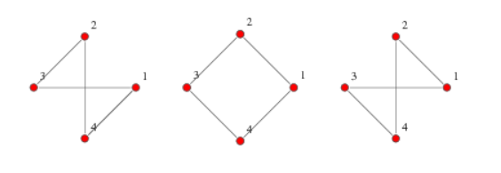

Solution.

import networkx as nx  
import matplotlib.pyplot as plt  
G = nx.Graph()  
G.add_edges_from(  
 [('1', '4'),('4','2'),('3','4')])  
nx.draw(G, with_labels=True)  
plt.show()

1. Given the graph

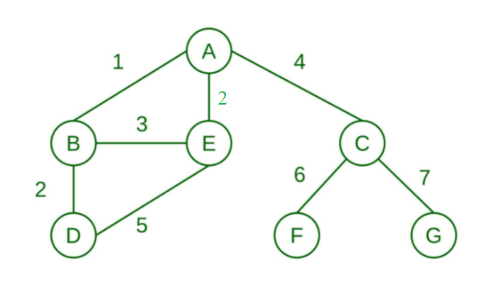

a. Redraw the graph

import networkx as nx  
import matplotlib.pyplot as plt  
G = nx.Graph()  
G.add_edge('A', 'B', weight=1)  
G.add_edge('B', 'D', weight=2)  
G.add_edge('B', 'E', weight=3)  
G.add_edge('D', 'E', weight=5)  
G.add_edge('A', 'E', weight=2)  
G.add_edge('A', 'C', weight=4)  
G.add_edge('C', 'F', weight=6)  
G.add_edge('C', 'G', weight=7)  
nx.draw(G, with_labels=True)  
  
plt.show()

b. Find shortest path from A to D; from G to D; from D to C.

import networkx as nx  
import matplotlib.pyplot as plt  
G = nx.Graph()  
G.add_edge('A', 'B', weight=1)  
G.add_edge('B', 'D', weight=2)  
G.add_edge('B', 'E', weight=3)  
G.add_edge('D', 'E', weight=5)  
G.add_edge('A', 'E', weight=2)  
G.add_edge('A', 'C', weight=4)  
G.add_edge('C', 'F', weight=6)  
G.add_edge('C', 'G', weight=7)  
print(nx.shortest_path(G, 'A', 'D', weight='weight'))

1. Given the graph

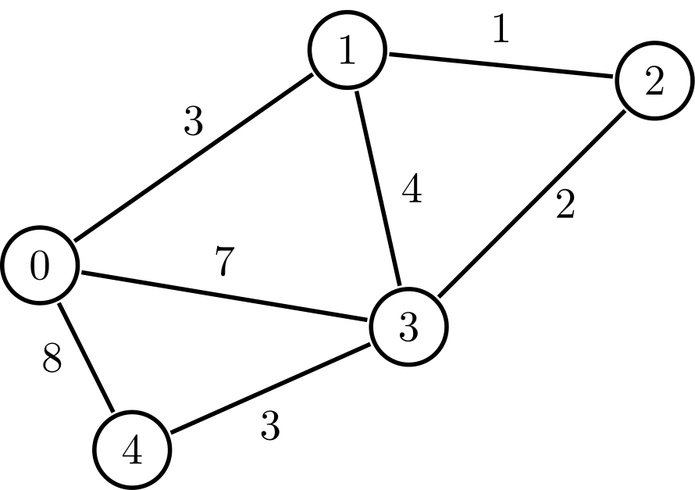

a. Redraw the graph.

b. Find shortest path from 1 to the other edges.

import networkx as nx  
import matplotlib.pyplot as plt  
G = nx.Graph()  
G.add_edge('0', '1', weight=3)  
G.add_edge('0', '4', weight=8)  
G.add_edge('0', '3', weight=7)  
G.add_edge('1', '2', weight=1)  
G.add_edge('1', '3', weight=4)  
G.add_edge('2', '3', weight=2)  
G.add_edge('3', '4', weight=3)  
print(nx.shortest_path(G, '1', '4', weight='weight'))

1. Given the graph

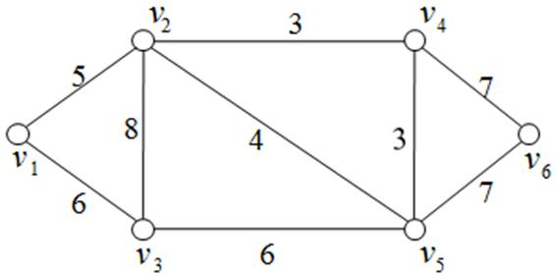

a. Redraw the graph.

b. Find shortest path from 1 to the other edges.

1. Given the graph

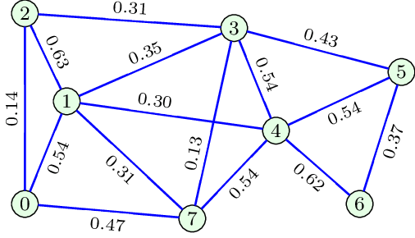

a. Redraw the graph.

b. Find shortest path from 1 to the other edges.

1. Given the graph

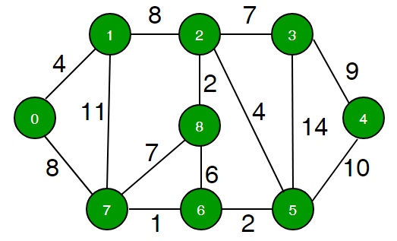

a. Redraw the graph.

b. Find shortest path from 1 to the other edges.

1. Given the graph

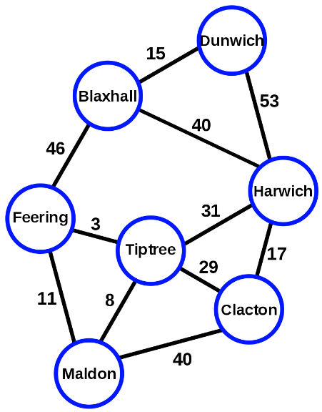

a. Redraw the graph.

1. Given the graph

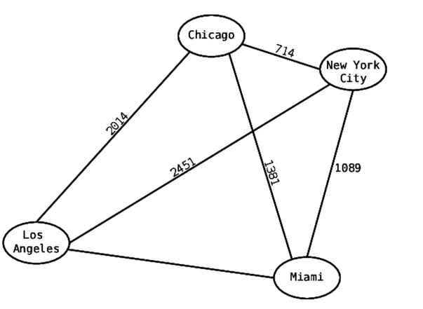

a. Redraw the graph.

b. Find shortest path from Chicageo to the other edges.

1. Given the graph

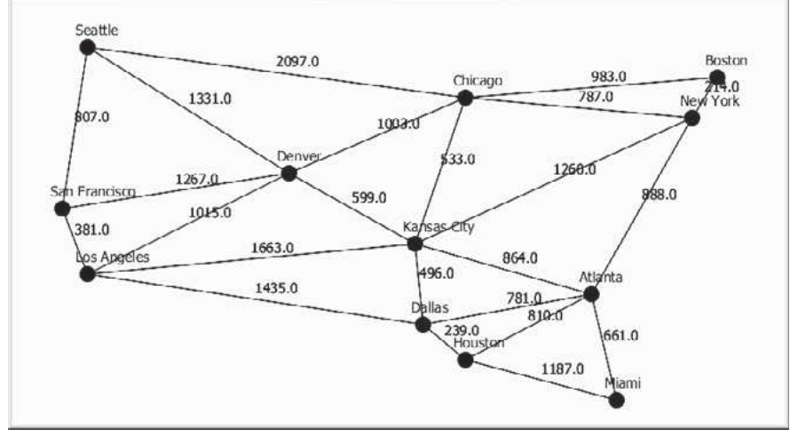

a. Redraw the graph.

b. Find shortest path from Seatle to the other Atlanta.